Evaluation of Garlic efficiency on precipitated lead chloride in hepatocytes of mice
Khalid Hamdan Gathwan¹, Sumaiah Ibrahim Hussein^{1*}, Muna Sachit Hashim²and Sara Majed Obaid³
¹Department of Basic Sciences, College of Dentistry, University of Baghdad, Baghdad-Iraq
² Department of Pathology, College of Veterinary, University of Baghdad, Baghdad-Iraq
³Department of Electrical power Technologies Engineering ,AL-Mamoun University College
ARTICLE INFO |  |  | ABSTRACT
Received: 30 / 06 /2023  Accepted: 28 / 07 / 2023  Available online: 11 / 12 / 2023  DOI: 000000000000000000000 |  |  | Like other soluble lead compounds, exposure to lead chloride may cause lead poisoning, In the current study, we seek to determine the effect of lead chloride on body and liver weight, as well as histological changes of the liver, in addition to the possibility of reducing the toxic effects of lead chloride by using natural products like garlic. Twenty-five healthy mice were divided into five groups: the first group was kept as an un-medicated control, while the second and third groups were given Lead chloride at a dose of 8.3 and 4.2 mg/kg, respectively; the fourth group were given only garlic at a dose of 200 mg/kg; and the fifth group were given lead chloride (8.3mg/kg) plus garlic in the same previous dose, the experiment continued for 21 days. This study's results show no significant difference in liver and body weight between groups except in the group that received a high dose of lead chloride. The histological changes in the liver showed focal granulomatous, congestion, necrosis space, hepatocyte degeneration, and inflammatory cells were also observed, especially in group that received high doses of Pbcl₂. The present study proved that heavy metals containing lead have toxicological effects on the liver, so this effect can be decreased by natural products like garlic, which has a large activity in removing toxins like this.  .
Keywords:
Lead chloride, Garlic, liver cells, histological changes, mice.

Copyright©Authors, 2022, College of Sciences, University of Anbar. This is an open-access article under the CC BY 4.0 license (http://creativecommons.org/licens es/by/4.0/).

1.Introduction:
Lead chloride (PbCl2) is an inorganic compound which is a white solid under ambient conditions, it is soluble in water. One of the most crucial lead-based reagents is lead chloride. It is used as a cathode for seawater batteries, as a flux for galvanizing steel, as a flame retardant in nylon wire coatings, and to eliminate H₂S and ozone from effluent gases [1], and as pigment, casoline and cosmetic.
Due to their distinctive chemical characteristics and high economic worth, industries use lead and lead-derived compounds extensively. From five million tons annually in 1970 to over 11 million tons in 2016, the use of lead has increased quickly. However, urban sources like homes, sewage treatment facilities, and waste management facilities can release lead directly into aquatic habitats [2]. According to numerous researches, lead can have negative consequences even at low concentrations [3, 4].

*Corresponding author at: Department of Basic Sciences, College of Dentistry, University of Baghdad, Baghdad-Iraq;
ORCID:https://orcid.org/0000-0000-0000-0000; Tel: +964 07813180403
E-mail address: sumaiahibraheem@codental.uobaghdad.edu.i

More proof has emerged demonstrating lead's harmful effects on human health, particularly on neurobehavioral functions. From childhood to maturity, the neurotoxicity of prolonged exposure to low quantities of lead can affect cognitive function [5,6]. Some research showed a link between lead exposure at low concentrations and children's attention-deficit/hyperactivity disorder (ADHD) [7]. When children are exposed to low amounts of lead over an extended period of time, the development of the central nervous system can be disturbed [8], as well as recent studies' epidemiological and experimental findings support the notion that inorganic lead compounds raise the risk of cancer [9]. As a result, lead toxicity has grown to be a significant problem for both environmental and human health.
It was widely known that garlic (Allium sativum) had anti-inflammatory, antifungal, and antiseptic properties [10]. Garlic has been discovered to have potential medical benefits, including lowering blood pressure, some protective effects against cardiovascular and cerebrovascular diseases, antioxidant and anti-aging, antitumor, and antiviral activities, improving glucose metabolism and liver function, and antibacterial activity [11,12]. The primary bioactive components of garlic were thio-sulfinate compounds, particularly diallyl thio-sulfonate (allicin) and S-allyl-cysteine sulfoxide (alliin), which were evaluated for garlic's active function [13]. About 70% of garlic's active ingredients include allicin, which may work as an antioxidant in the body [14],as well as, vitamin, minerals, flavonoids, ascorbic acid, sulphue and trace of iodine, addition to seventeen of essential amino acid [15], and many research were using garlic extract as antibacterial that lead to inhibition zone 100% [16].
The liver is one of the most significant solid organs in humans, serving a variety of purposes including maintaining metabolic homeostasis, producing nutrients like carbohydrates, fats, proteins, and vitamins, distributing those nutrients, storing them, and synthesizing proteins and other end products of metabolism, including drugs and toxins invading the liver cell cycle [17].
Several studies were decided the risk effect of lead chloride on liver [18,19, 20], this study will be conducted to demonstrate and determined the negative effect of lead chloride on the liver by using natural product like garlic.

2. Materials and methods:
2.1. Preparation of lead chloride solution
Lead chloride powder will be prepare by dissolving 1 g of lead chloride powder in 100 ml of distilled water as stock solution, two doses were prepared, high and low dose of Pbcl₂ (8.3 and 4.2)mg/kg body weight respectively.

2.2. Preparation of Garlic solution
Freshly peeled garlic was homogenized and 0.1 g was dissolved in 1 ml of distilled water, corresponding to 250 mg/kg body weight of animals [21].

2.3.Animal groups
Twenty five Balb /C mice in age of (2-3) months, weighing (34-37) g in animal house of our college. Animals were divided randomly into five groups of each with ( 5 ) mice as following:
1- The first group as negative control received orally phosphate buffer for 21 day.
2-The second group was receiving orally high concentration of lead chloride solution (8.3mg/kg) for21day
3-The third group was receiving orally low concentration of lead chloride solution (4.2mg/kg) for21day.
4- The fourth group was receiving orally Garlic solution for 21 day.
5- The fifth group was receiving orally lead chloride solution (8.3mg/kg) plus Garlicfor21day.
The mice were maintained on standard laboratory animal diet pellets and the mice weight was taken at the beginning and end of the experiment. After 21 day, all groups of mice were killed by dislocation of the neck at intervals and scarifying for take the liver, liver weight also was taken.

2.4. Body weighing
Body weight was recorded at the first and end of the experiment and for all groups.

2.5. Liver weighing
Liver weight was recorded at the end of the experiment and for all groups.

2.6. Statistical analysis
The Statistical Analysis System, SPSS will be used to identify effect of Lead chloride and Garlic on body and liver weight. Least significant difference between means in this study [22].

2.7. Histopathological study
After animal scarification, liver tissue was taking and kept in 10% formalin to prevent any changes in tissues structure. The histopathologic examination was carried out according to [23]. Small pieces of tissue were taken and placed in plastic cassettes, then washed with tap water and labeled. Dehydration of the specimen was done by using grades of ethanol 70 %, 80 %, 90 %, 95 %, and 100 % (2 hours each). The specimen was treated with xylene for 2h before dipping in liquid paraffin at 55- 60°C for 4h. Tissue was embedded in paraffin and paraffin blocks are left for 1-2 days in -4Ċ. Sections (4–5 μm) were stained with eosin and hematoxylin. Finaly, the slides were examined by taking different fields under magnification power of (10x, 20x and 40x) and the abnormal changes of tissues were record.

3. Results and Discussions
In this study the results of liver weight show in Figure (1) which revealed that liver weight in group that received only garlic as the same in negative control group, and close to what appeared in group which take Garlic with lead chloride, as well as in group that take only lead chloride but at low dose, while, the liver weight was decreased in group that take high dose of lead chloride for three weeks, this is due to harm effect of lead chloride on liver in dose dependent manner.
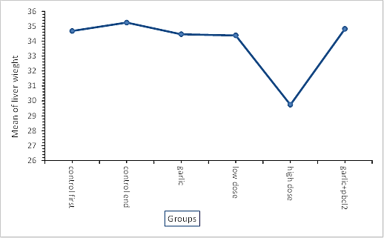
Figure (1) show the correlation between five groups and liver weight

Regarding to body weight under lead chloride, and after 21 days of experiment, all groups showed similar weights expect the group that take high dose of lead chloride (Figure 2), because the exposure to lead compound in adult may be lead poisoning and increased risk of high blood pressure, heart disease, decline in cognitive function, anxiety, and depression that lead to loss of weight to anemia, hypertension, kidney dysfunction and Subclinical peripheral neuropathy and this, in turn, leads to loss of weight [24].
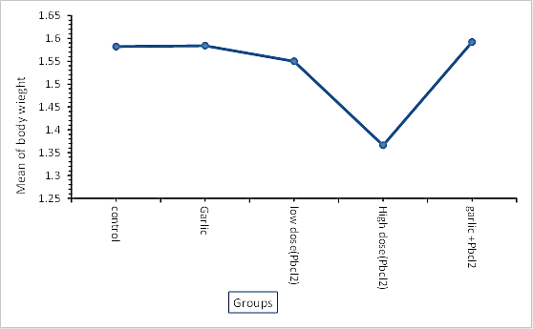
Figure (2) show the correlation between five groups and body weight

The results of histopathological liver study show normal tissue in negative control group (Figure 3), as well as, unnoticeable change and may be closer to normal in mice group that received only garlic solution (Figure 4). While the alteration histopathological is clear as focal granulomatous lesion appear in many lobes mainly in portal area and others granuloma appear within necrosis space with degenerated hepatocytes appears swollen and enclosed to area of granuloma's zone in group that received high dose of lead chloride (Figure 5), this result is in the same line with study of [25], which decided that the effect of lead compound may be lead to severe damage in hepatocytes of mice due to lobular disarrangement , congestion, moderate portal and lobular hepatitis .
After 21 days of experiment, the histological structure of liver in group which took orally low dose of lead chloride showed cuffing of inflammatory cells around blood vessels which appear dilated and congested, as well as degenerated in hepatocytes due to loss of sinusoidal and have dark nuclei that named cloudy swelling (Figure 6), the appearance of inflammatory cells may be due to interact lead with enzymes and proteins of liver tissue, interfering with the mechanism of antioxidant defense to produce a traditional inflammatory response as a result of the generation of reactive oxygen species( ROS) [26].
However, the causes of pathological changes in the liver tissue could be as a result to lead action on the content of DNA, liver glycogen and portability of lead to convert amino acids into proteins [27].
Other study has suggested that the reason of the pathophysiology changes in the liver may due to oxidative stress, or programmed cell death (apoptosis), Although the mechanism of lead action that causing hepatic toxicity is not much clear [28].
After 21 days of took garlic solution plus 8.3 mg of lead chloride, the histopathological changes showed regeneration of hepatocytes appear enlarged and dark nuclei due to mitosis although the high dose of lead chloride, but others hepatocytes still swelling and loss of sinusoids which refer to regeneration which indicates the effect of garlic in returning hepatocytes to normal (Figure 7), this regeneration may be due to the presence of organ sulfur compounds in garlic that have many effect on drug metabolizing enzymes, antioxidant properties, antimicrobial, antithrombotic, hypolipidemic, antiarthritic, hypoglycemic and antitumor activity[29]. Finally, This study is in agreement with other studies that emphasize decreasing chemical toxicity by using natural products[30].
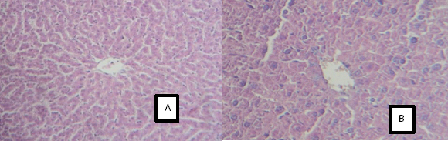
Figure (3) Liver section of control group shows normal structure and appearance A:(100x, H&E) B: 400XH&E).
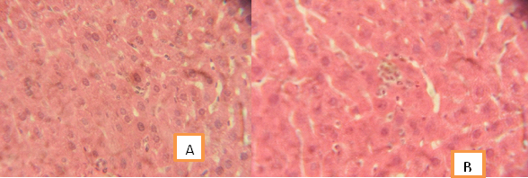
Figure (4):Histopathological section in liver showed A &B nearly to normal with no clear lesions in group that received only Garlic solution.A(200x,H&E); B:400X H&E.
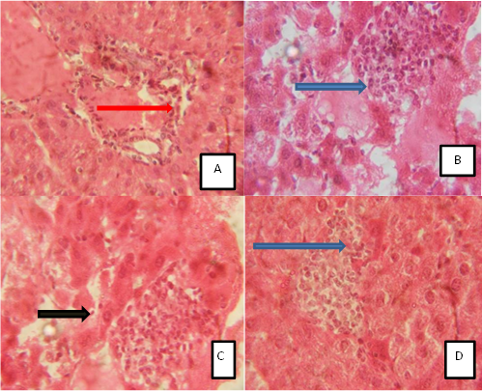
Figure(5) Histopathological section(A;B;C;D) of liver in mice of group that received high dose of lead chloride, shows many lobes in portal area(red arrow),granuloma space with necrosis(blue arrow)and degenerated hepatocytes with swollen and enclosed of granuloma zone (black arrow).(400x,H&E)
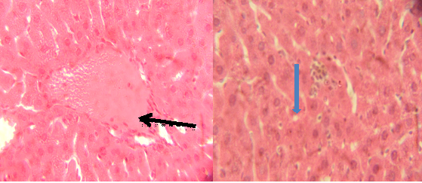
Figure(6):Histopathological section of liver from mice of group that received low dose of lead chloride show cuffing of inflammatory cells with congested central vein(black arrow),degeneration of hepatocytes appear as cloudy swelling(blue arrow) (400x,H&E).
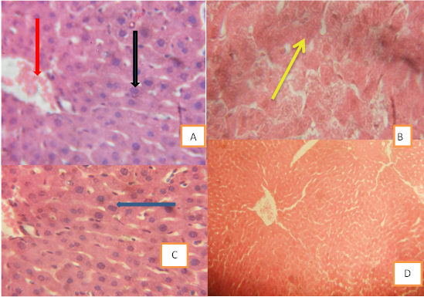
Figure (7) Histopathological section of liver from mice of a group which received lead chloride and garlic showed A: degeneration of hepatocytes which appear swelling (Black arrow) nearly to congested central vein (red arrow). B: cloudy swelling still presented in others hepatocytes (yellow arrow). C: regeneration in some hepatocytes(blue arrow). D: Restore to normal appearance.(100x&400x,H&E).
Conclusion:
Garlic solution aid in moderating the toxic effects of lead compound on hepatocytes through regenerative processes in which newly form hepatocytes producing and restore to normal appearance gradually. Many studies are required on the effectiveness of garlic and especially the active substances it contains, which can be converted into nanomaterials and used as anti-toxic agents
References:
[1] Muthuselvi C, AnbuselviT, Pandiarajan S (2016). Synthesis and characterization of lead (II) chloride and lead (II) carbonate nanoparticles. International Online Multidisciplinary Journal,5:1-13.
[2] Thi NH, Thi NA, Audira G et al (2020). Chronic Exposure to Low Concentration Lead Chloride-Induced Anxiety and Loss of Aggression and Memory in Zebra fish . Int. J. Mol. Sci ,21,1844. doi: 10.3390/ijms21051844.
[3] Gupta S, JenaV, Jena S et al (2013). Assessment of heavy metal contents of green leafy vegetables. Croat. J. Food Sci. Technol,5:53–60.
[4] Xia J, Jin C, Pan Z et al (2018). Chronic exposure to low concentrations of lead induces metabolic disorder and dysbiosis of the gut micro biota in mice. Sci. Total Environ, 631:439–448. doi: 10.1016/j.scitotenv.2018.03.053.
[5] Chen J, Chen Y, Liu W et al (2012). Developmental lead acetate exposure induces embryonic toxicity and memory deficit in adult zebra fish . Neurotoxic. Teratol,34: 581–586. DOI: 10.1016/j.ntt.2012.09.001.
[6] Roy NM, DeWolf S, Carneiro B (2015). Evaluation of the developmental toxicity of lead in the Dania rerio body. Aquatic toxicology . Topical,158,138–148 http://dx.doi.org/doi:10.1016/j.aquatox.2014.10.026.
[7] Eubig P.A, Aguiar A, Schantz SL (2010). Lead and PCBs as risk factors for attention deficit/hyperactivity disorder. Environ. Health Percept,118:1654–1667. DOI: 10.1289/ehp.0901852.
[8] Lee J, Freeman JL(2014). Zebra fish as a model for investigating developmental lead (Pb) neurotoxicity as a risk factor in adult neurodegenerative disease: A mini-Review. Neurotoxic,43:57–64.
[9] Silbergeld EK,Waalkes M, Rice JM (2000). Lead as a carcinogenic: Experimental evidence and mechanism of action. American Journal of Industrial Medicine ,38, 316-323. DOI: 10.1002/1097-0274(200009)38:3<316::aid-ajim11>3.0.co;2-p
[10] Correa MJ, Burbano Moreano JJ, Guardianelli LM(2021). Garlic: A natural bread improver for wheat bread with a high level of resistant starch. J. Food Process. Preserve, 45: e15519. https://doi.org/10.1111/jfpp.15519
[11] Thuy BT, My TT, Hai NT et al (2020). Investigation into SARS-CoV-2 Resistance of Compounds in Garlic Essential Oil. ACS Omega, 5:8312–8320. https://doi.org/10.1021/acsomega.0c00772.
[12] Chen J, Huang G (2019). Antioxidant activities of garlic polysaccharide and its phosphorylated derivative. Int. J. Biol. Macromol,125: 432–435. https://doi.org/10.1016/j.ijbiomac.2018.12.073.
[13] Shang A, Cao SY, Xu XY et al (2019). Bioactive Compounds and Biological Functions of Garlic (Allium sativum L.). Foods, 8, 246. doi: 10.3390/foods8070246.
[14] Hamed HS, Ismal SM, Faggio C (2021). Effect of allicin on antioxidant defense system, and immune response after carbofuran exposure in Nile tilapia, Oreochromis niloticus. Comp. Biochem. Physiol. C Toxicol. Pharmacol, 240, 108919.
[15] Shakir MA, Al-Rawi WA (2017). Effect of Garlic and licorice root extract on leaves mineral and hormonal content of pear transplants. The Iraqi Journal of Agricultural Sciences,48: 131-143.
[16] Al-Ani, R . A.; Juber, K.S . and Al-janabi, RG (2007). Effect of Garlic extract, beltanol and agromycin on the bacteria Ralstonia solanacerum. Iraqi Journal of Agriculture Sciences,5(38):55-57.
[17] Buechter M & Gerken G (2022). Liver Function—How to Screen and to Diagnose: Insights from Personal Experiences, Controlled Clinical Studies and Future Perspectives. J Pers Med,12,1657. https://doi.org/10.3390/jpm12101657.
[18] ChangW J (2013). The Relationship of Liver Function Tests to Mixed Exposure to Lead and Organic Solvents. Ann. Occup. Environ .Med ,25.doi:10.1186/2052-4374-25-5.
[19] Jarar MM, Taib NT (2012). Histological and histochemical alterations in the liver induced by lead chronic toxicity. Saudi. Biol. Sci,19:203-210.
[20] Andjelkovic M,Djordjevic,AB,Antonijevic E et al (2019). Toxic Effect of Acute Cadmium and Lead Exposure in Rat Blood, Liver, and Kidney. Int. J. Environ. Res. Public Health, 16: 274, doi: 10.3390/ijerph16020274.
[21] Banerjee SK, Maulik M, Manchanda SC et al (2001). Garlic-induced alteration in rat liver and kidney morphology and associated changes in endogenous antioxidant status. Food Chem. Toxicol. ,39:793-797, https://doi.org/10.1016/S0278-6915(01)00018-7.
[22] SAS.Statistical Analysis System, User,s Guide. Statistical.Version 9.6 th ed.SAS. Inst. Inc 2018; Cary.N.C.USA.
[23] Bancroft J D, Gamble M (2008). Theory and practice of histological techniques, Churchill Livingstone, Elsevier, China.
[24] Walter K (2023). What is lead poising? JAMA,;329(12):1040. doi:10.1001/jama.2023.1543.
[25] Abd RN (2016) Study the toxic effect of lead acetate on kidney, lung and liver tissues in Albino mice Muss musculus. J. of Karbala University ,14:206-214.
[26] Johar D, Roth JC, Bay GH et al (2004). Inflammatory response, reactive oxygen species, programmed (necrotic-like and apoptotic) cell death and cancer. Rocz. Akad. Med. Bialymst , 49: 31-39.
[27] Shalan MG, Mustafa MS, Hassouna MM et al (2005). Amelioration of lead toxicity on rat liver with vitamin C and.silymarin supplements. Toxicology, 206, 1-15. doi: 10.1016/j.tox.2004.07.006.
[28] SharmaV, Pandey D (2010). Protective Role of Tinospora ordifolia against Lead-Induced Hepatotoxicity. Toxicol. Int, 17,12-17. doi: 10.4103/0971-6580.68343.
[29] ThomsonM, Ali M (2003). Garlic [Allium sativum]: a review of its potential use as an anti-cancer agent. Cur. Cancer Drug Targets,3:67-81, DOI: 10.2174/1568009033333736.
[30] Farhan,A S(2019).Alcohol extract of Tribulus terrestris ameliorates liver of mice exposed to cadmium acetate. J. Of University Of Anbar For Pure Science, 13 (2):10-15.

تقييم كفاءة الثوم على كلوريد الرصاص المترسب في خلايا كبد الفئران
خالد حمدان غثوان ¹ ، سمية ابراهيم حسين ¹ ، منى ساجت هاشم ²، سارة ماجد عبيد ³
¹ قسم العلوم الاساسية، كلية طب الاسنان، جامعة بغداد/بغداد-العراق
² قسم الامراض وامراض الدواجن، كلية الطب البيطري،جامعة بغداد- العراق
³ قسم هندسة تقنيات القدرة الكهربائية، كلية المأمون الجامعة
sumaiahibraheem@codental.uobaghdad.edu.iq , kh201295@codental.uobaghdad.edu.iq
, mona.sha@covm.uobaghdad.edu.iq , sara.m.obaid@almamonuc.edu.iq
الخلاصة :
مثل مركبات الرصاص الأخرى القابلة للذوبان ، فان التعرض لكلوريد الرصاص قد يسبب التسمم ، في الدراسة الحالية نبحث عن تأثير كلوريد الرصاص على وزن الجسم والكبد ، وكذلك التغيرات النسيجية للكبد ، بالإضافة إلى إمكانية تقليل اثار سموم كلوريد الرصاص بمنتج طبيعي مثل الثوم. تم تقسيم خمسة وعشرين فأرًا سليمًا إلى خمس مجموعات وتم الاحتفاظ بالمجموعة الأولى على أنها مجموعة السيطرة غير معالجة، بينما أعطيت المجموعتان الثانية والثالثة كلوريد الرصاص بجرعة 8.3 و 4.2 ملغرام لكل كيلو من وزن الجسم على التوالي ، وأعطيت المجموعة الرابعة الثوم فقط بجرعة 200 ملغرام لكل كيلو من وزن الجسم وأعطيت المجموعة الخامسة كلوريد الرصاص (8.3 ملغرام لكل كيلو من وزن الجسم) مع الثوم وبنفس الجرعة السابقة. اظهرت نتائج هذه الدراسة أنه لا يوجد فرق معنوي بين اوزن الجسم والكبد بين المجاميع ماعدا المجموعة التي تلقت جرعة عالية من كلوريد الرصاص. وبالنسبة للتغيرات النسيجية في الكبد فقد لوحظت هذه الدراسة أيضا وجود ورم حبيبي بؤري واحتقان ونخر وتنكس الخلايا الكبدية والتهابات خصوصا في المجموعة التي تلقت جرعة عالية من كلوريد الرصاص. أثبتت الدراسة الحالية أن المعادن الثقيلة المحتوية على الرصاص لها تأثيرات سمية على الكبد ، لذلك يمكن أن يتناقص هذا التأثير بالمنتج الطبيعي مثل الثوم الذي له فعالية كبيرة في ازالة بعض المركبات السامة.

الكلمات المفتاحية: كلوريد الرصاص، الثوم، خلايا الكبد، التغيرات النسيجية، الفئران.

