|  |  |  |
| --- | --- | --- |
| D:\مجلة\last\شعار المجلة.jpg**Study and Evaluating the Physical and Chemical Properties of Clay of Injana Formation in Al-Anbar Governorate - Western Iraq for the Purposes Some Ceramic Industries.**  **Ahmed A. Mansor* and Mohammed A. Al-Nuaimy**  1Department of Applied Geology, College of Science, University of Anbar, Iraq; | | |
| **ARTICLE INFO** | |  | **ABSTRACT** | |
| Received: 09 / 05 /2023  Accepted: 22 / 05/ 2023  Available online: 06 / 06 / 2023   |  | | --- | | DOI: 10.37652/juaps.000000 | | |  | The clays of Injana formation are exposed in Al-Anbar Governorate-western Iraq. The aims of this study is evaluating the physical and chemical properties etc. and comparing the results with the standard specifications to indicate its suitability to ceramic industries. (13) mixtures were prepared differ from it by additions of different percent of sand and burn in four temperatures (850, 950, 1000, 1100) C° to show what is the best mixture and best burning temperature that lead to results close to standards specifications. The results of physical examinations are range between , Linear shrinkage (-0.5–0.92), Apparent porosity (11.1-35.7), efflorescence (nil to medium), compressive strength (16.1-30) Nt./mm2. The main oxides for study area are range between , SiO2 (36.15-45.10), Al2O3 (8.64-14.05), CaO (17.05-24.79), Fe2O3 (0-7.25), TiO2 (0.69-1.01), K2O (1.61-3.14), Na2O (0.32-2.11), SO3 (0.23-1.32) and Cl (0-0.47). The best burning temperature is 950C°. The engineering test results (Atterberg limit) shows that the clays of study area have super plasticity depending on classification of (Budinkov,1964), i.e. this clays can be formed and take on a plasticity suitable for ceramic industries. By comparing the results of physical properties of fired brick with the Iraqi standard specification No. 25 for year 1988, showing the clays of study area are suitable for brick industry with category class (A) Except the sample G5,G6 are failed for brick industry because using red sand that mixed with clay, which this sand contain the salts that failure the sample.. | |
| **Keywords:**  *Ceramic industries,*  *Clays,*  *Brick clays,*  *Clastic of Injana formation,*  Copyright©Authors, 2023, College of Sciences, University of Anbar. This is an open-access article under the CC BY 4.0 license ([http://creativecommons.org/licens es/by/4.0/](http://creativecommons.org/licens%20es/by/4.0/)). | |  |

1. **Introduction**

In the last years witnessed a remarkable increase in urban expansion, which led to an increase in the demand for materials in general, including ceramic industry. That is what made us research this topic . We use clay of Injana formation (Late Miocene) to studying because widespread and economically important of this formation in Iraq.

*Corresponding author at: Department of Applied Geology, College of Science, University of Anbar, Iraq.;

ORCID:https://orcid.org/0000-0000-00000-

;Tel:+964000000000000000

[E-mail](mailto:Sulaf.mohammed@univsul.edu.iq) address: [ahm21s4001@uoanbar.edu.iq](mailto:ahm21s4001@uoanbar.edu.iq)

Clays are the main raw materials that used in the various of ceramic industries , such as bricks, tiles, abrasives, pottery, porcelain, and refractories ... etc[1].

Use of clays in ceramic industries because it characteristic of plasticity, and it also gives to ceramic bodies hardness and strength after firing[2]. The interaction of clay with other minerals during firing, including silica, and other molten materials such as feldspar, where this is responsible for the formation of the final product [2] .

The study areas within Anbar Governorate-west of Iraq, (Al-Hejaira area that located near Habbaniea lake approximately 10 km to the east, ​​Hsaiba Alsharqiea area which located approximately 14 km to the east of ramadi city, and Al-Chiffa area which is located 12 km west of Fallouja city) Fig.1.

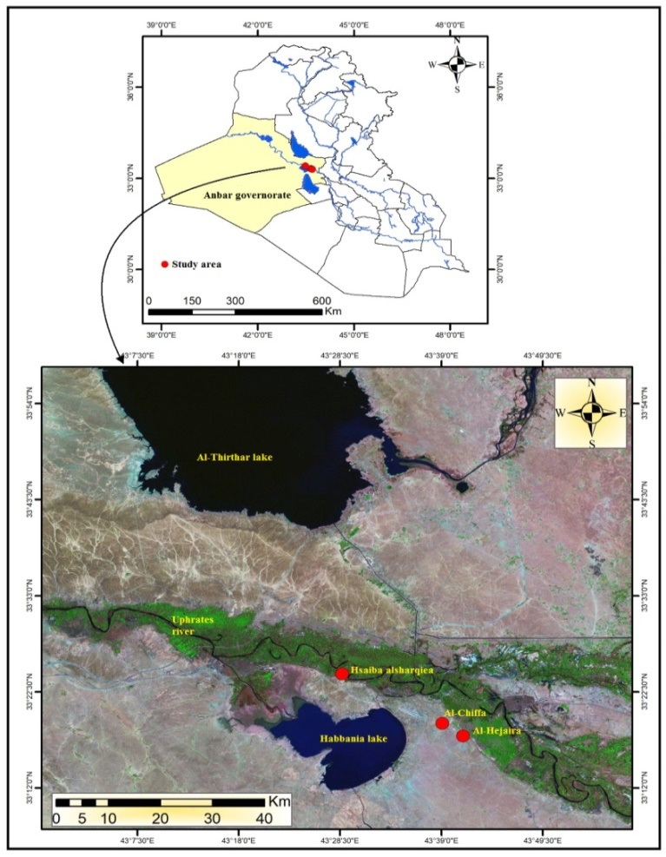

Fig.1. Location map of study area

1. **Geological setting :**

The age of Injana formation is Late Miocene (Jassim & Goff,2006) . the type locality is located along the northeastern limb of Himreen south anticline at Injana area [3] . The thickness of the formation in the typical section is about 620 meters, while the thickness of the formation is about 20 meters in the Habbaniyah area [4] .

This clastic unit represents the transitional stage from the limited marine environment in the Fatha formation to the terrestrial environments. The formation consists of different rock components, most of which are red claystone or gray siltstone or sands, or red , gray sandstone. The deposition environments of this formation may be different. Lagoons are initially transformed into marine, continental environments, and in most cases they may be mountainous environments [6].

The lower limit of the formation is gradational with Fatha formation. and the upper limit of the formation is also gradational with Muqdadiya formation with the appearance of gravely sandstone [4] .

Three locations (exposures) of sedimentation of Injana Formation clays were sampled:

The first location, Al-Hujaira area, to the east of Habbaniyah Lake, where two different beds were sampled according to coordinate (Lattitude 33:17.4282 , Longitude 43:41.1606) . The first layer, was yellow clays, Moderate bedding, massive bed . The second layer, was a red clays, stratified .

The second location is Hsaiba Alsharqiea area, according to the coordinate (Lattitude 33:24.29178 – Longitude 43:28.51199), which is a layers of red clay overlapping with silts.

Third location is Al-Chiffa area, according to the coordinates (lattitude 33:19.0158 – Longitude 43:39.0804), which is red, solid, cohesive and stratified clays . The lithology of study area consists of clay beds interbedded with silty clay beds and sand beds .

1. **Materials and Methods**

Firstly Several field work were done for the sampling process, where Three clays exposure sites were sampled (Al-Hejaira area, ​​Hsaiba alsharqiea area, and Al-Chiffa area), These sites were chosen based on the geological map of Anbar Governorate – the plat of Ramadi [5].

Also, red sand was brought for the purpose of treatments process for clays in the event of their failure, by using this sand , it was found invalid it for the industry because of low percentage of silica (SiO2), which about 50%, and high percentage of (CaO), which reached to 35%, so replace it with white silica sand that brought from the Obeid formation (Umm Erdhuma region) . This type of sand was used for laboratory experiments, where the percentage of silica reaches more than 97%.

After completing the field work and bringing the samples to the laboratory , the samples were dried in a drying oven at a temperature of (105 – 110) degrees and grinding it into fine sizes by using grinding machine (Tema mill), and then mixed the samples well to homogenizing it and put it in nylon bags so as not to take moisture from the air. chemical analysis (XRF) were done in the laboratories of the Ministry of Science and Technology and in the German laboratory in the Department of Geology / College of Science / University of Baghdad , Where the geochemical properties have an important role in the ceramic industries, as determining the proportions of the main oxides of clays helps in understanding the behavior of the ceramic body during firing [7] .

Also grain size were done for the clays and **twelve** mixture were prepared differing among it in the sand add percentage. And physical properties (efflorescance, water absorption, apparent porosity, bulk density, compressive strength for the fired bricks) and engineering analysis (Atterberg limits) were done in the engineering laboratory in the applied geology department . and then compare the results with the standard specifications for clays , clay from Nahrawan area were also brought in because clays of Nahrawan are suitable for brick industry and are classified with category class (A) [8] and its used to brick industry to present day .

**4. Results and discussion :**

**4.1. Chemical analysis :**

The results of the chemical analyzes Table1 showed that SiO2 ranges in the study samples between (36.15 – 45.10), where this oxide constitutes the highest percentage in all the studied samples because silica represents the highest percentage in the clay samples as it is included in the crystal structure For clay minerals and within the chemical composition of feldspar, as well as free silica in the form of quartz. Al2O3 range in the study samples between (8.64 – 14.05) % . CaO range between (17.05 – 24.79) % . Fe2O3 range between (0-7.25) % Its effect is on the color of the burned samples, as it gives the red dye to the fired bricks at temperatures less than 800˚C. As for TiO2, its percentage ranges between (0.69 – 1.01) % , which is a very small percentage, It is expected that the presence of titanium in clay minerals is due to the substitution of (Ti+4) instead of ions (Al+3) ions in the crystalline structure of clay minerals due to their close ionic radius [9] .

Na2O, K2O, SO3, and Cl, these oxides are found in the studied samples in small percentages , the K2O percentage ranges between (1.61 – 3.14). The Na2O range between (0.32 – 2.11) . The ratio of SO3 ranges between (0.23 – 1.32) and Cl between (0–0.47). Table 1 showing the main oxides study area clays .

Table 1: Main oxides to study area

|  |  |  |  |  |  |  |  |
| --- | --- | --- | --- | --- | --- | --- | --- |
| **Oxides** | **Al-Hejaira1** | **Al-Hejaira 2** | **Hsaiba alsharqiea** | **Al-Chiffa** | **Red Sand1**  **Area 1**  **%** | **Red Sand 2**  **Area 2**  **%** | **Silica Sand**  **Av. %** |
| **Na2O** | **1.96** | **0.32** | **2.11** | **1.84** | **1.74** | **0.79** |  |
| **MgO** | **4.74** | **5.62** | **10.56** | **5.04** | **3.06** | **2.08** |  |
| **Al2O3** | **9.3** | **14.05** | **13.02** | **8.64** | **4.80** | **4.03** | **0.66** |
| **SiO2** | **37.37** | **44.44** | **45.10** | **36.15** | **47.83** | **53.74** | **97.38** |
| **P2O5** | **0.13** | **0.14** | **0.18** | **0.13** | **0.10** | **0.11** |  |
| **SO3** | **0.23** | **0.25** | **1.32** | **1.02** | **3.96** | **0.64** |  |
| **Cl** | **0.08** | **ــــــــــ** | **0.47** | **0.25** | **0.20** | **0.07** |  |
| **K2O** | **3.14** | **1.61** | **1.93** | **3.06** | **0.68** | **0.41** |  |
| **CaO** | **17.05** | **24.79** | **17.81** | **19.96** | **34.85** | **36.10** | **0.39** |
| **TiO2** | **0.89** | **0.78** | **0.69** | **1.01** | **0.41** | **0.58** |  |
| **Fe2O3** | **ــــــــــ** | **7.25** | **6.53** | **ــــــــــ** | **2.07** | **1.17** | **0.10** |

the results of the chemical analysis have been compared with the results of the chemical analysis of Nahrawan clays Fig.2, where the Nahrawan clays are suitable for brick industry and are classified with category class (A) [8], as shown in Table 2 .

Table 2: Main oxides of Nahrawan area [8]

|  |  |  |  |  |  |  |  |  |  |
| --- | --- | --- | --- | --- | --- | --- | --- | --- | --- |
| **Oxides** | **Na2O %** | **K2O %** | **SO3 %** | **Fe2O3 %** | **Al2O3 %** | **MgO %** | **CaO %** | **SiO2 %** | **TiO2 %** |
| **Av.** | **0.97** | **1.17** | **0.78** | **4.01** | **8.97** | **4.05** | **20.17** | **38.82** | **0.5** |

The results of the chemical analysis shown in Table1, showed that the oxides of the clays of the study area are close to the results of the oxides of Nahrawan area, which are listed in Table 2, this is a primary indicator of the validity of clays of study area for the purposes of ceramic industries .

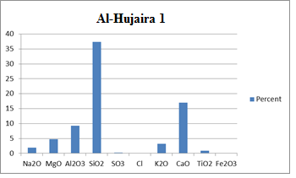

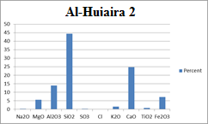

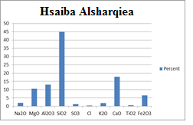

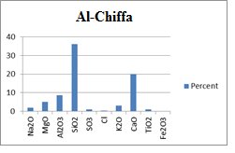

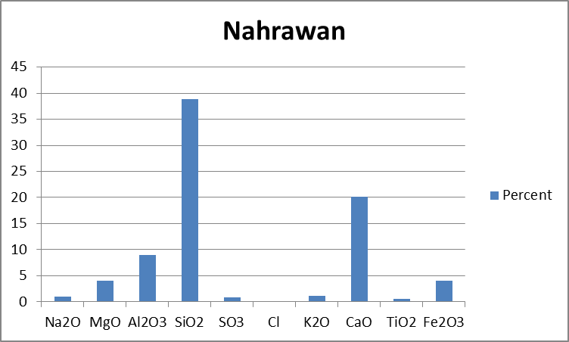

Figure 2 :Bar charts for major oxides concentrations of the studies area and Nahrawan clays

**4.2 Grain size analysis :**

After grinding the clays in the size less than 63 microns, a grain size analysis was carried out using the hydrometer method, the results were shown in table 3.

Where the fine the size of the clay particles means greater flexibility and greater ability to interact [10].

Table 3: grain size for clay samples

|  |  |  |  |
| --- | --- | --- | --- |
|  | **Sand Percent %** | **Silt Percent %** | **Clay Percent %** |
| **Al-Hejaira** | **0** | **3.6** | **96.4** |
| **Hsaiba alsharqiea** | **0.4** | **4.5** | **95.1** |
| **Al-Chiffa** | **1.3** | **7.8** | **90.9** |

**4.3 Atterberg Limits:**

Atterberg identified the consistency states in which the soil can exist by transform from the wet state to the dry state, where the soil transform from the liquid state to the semi-liquid state and then to the plastic state , then semi-solid, and finally solid.

Atterberg identified six limits for fine-grained soil, which are (upper limit of viscous flow, liquid limit, sticky limit, cohesion limit, plastic limit, and shrinkage limit). In current engineering usage, the term liquid limit and plastic limit is usually used, and in some sources the term shrinkage limit is used, [11] .

Plastic limit is defined as the limit of the water content at which the soil transforms from the plastic state to the semi-solid state Fig. 3 , or it is the water content of the sample at which the soil cracks when wrapped in the form of a thread with a diameter of 3.2 mm. plasticity is important characteristic for ceramic industry because the clays that contain good plasticity become easy to forming without crack appearance [12].

The plasticity limit and liquid limit are checked on the soil that passes through the sieve with a size of 425 micrometer (according to the American standard ASTM) [11] .

The soil is become non-plastic if it cannot form filaments with a diameter of 3.2 mm or less at any moisture content [13]. This experiment is carried out by taking a certain weight of the soil and adding a certain amount of water and mixing it well so that the water is homogeneous with all the soil, and then the fine-grained sample is wrapped by hand in the form of a thread on a flat, smooth, non-porous surface until the thread reaches a thickness of 3.2 mm. Where if the thread breaks before reaching this diameter, this means that the moisture content is low and requires an increase the moisture and a good homogenization of the soil with moisture and a repeat of the experiment, but if the thread reaches a thickness of less than 3.2 It did not crack, which means that the moisture content is high and requires the addition of a small amount of soil for the purpose of reducing the moisture content. The experiment is repeated several times until the thread becomes cracked with a thickness of 3.2 mm. The experiment is repeated three times for the purpose of taking the average moisture content for three readings. The moisture content of the sample is calculated by placing the soil in a small container after taking the weight of the container empty, then weighing the container and sample together, then drying the sample in the drying oven for 24 hours, then the weight of the container and sample was taken after drying, and the equation (1) is applied to find Moisture content of the sample as shown in Table 4.

W.C(%) = . 100 ……….. (1)

where as : **W.C** is water content

**w1** is empty can weight

**w2** is weight of can and wet sample

**w3** is weight of can and dry sample

Table 4: water content for plasticity test

|  |  |
| --- | --- |
| **Moisture content** | **Area** |
| **31** | **Al-Hujaira** |
| **20** | **Hsaiba Alsharqiea** |
| **27.5** | **Al-Chiffa** |

The liquid limit was defined as the limit of the water content (moisture content) at which the soil transform from the plastic to the liquid Fig.3 . This transformation does not happen suddenly, but rather gradually, to several differences in the water contents. the liquid limit was measured according to the Cazagrande method.

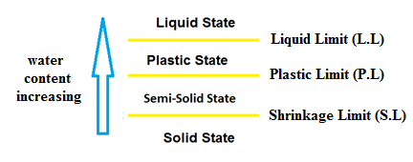

Fig.3 sketch shaws Atterberg limits

4.3.1 **Cazagrande method :**

Use this method to measurement liquid limit by placing the clay in a round metal container with a diameter of 10-12 cm (Cazagrande cup) and making it horizontally level, then making a groove in the clay with a width of 2 mm by using a special tool, then hitting the container through a crowbar at a rate of two blows per second for the purpose of closing the groove, and record the number of blows until the groove is closed, and the water content is

calculated (In the same manner as above) . repeated this experiment three times and represented graphically on a Semi-log paper (Fig. 3) by putting the number of blows on the log division and water contain on the normal division and draw straight line by connecting the three points and Extraction of moisture content on the number of blows 25 table 5 .

Table 5: liquid limit value

|  |  |  |  |
| --- | --- | --- | --- |
| **Al-Chiffa** | **Hsaiba Alsharqiea** | **Al-Hejaira** | **Area** |
| **65** | **53** | **70** | **Liquid limit** |

**4.3.2 Plasticity index (P.I) :**

It is the numerical difference in moisture content between liquid limit and plastic limit as in the equation (2) :

P.I. = L.L. – P.L. …………… (2)

Where :

P.I is Plastic index

L.L is Liquid limit

P.L is Plastic limit

by comparing the results of the plasticity index shown in Table 6 with the classification of Budinkov [14] shown in Table 7, it is clear that the study areas (Alhejaira , Hsaiba alsharqiea , Al-Chiffa) showed super plasticity,. This means that this clays of can be formed and take on a plasticity suitable for ceramic industries .

Table 6: Atterberg limits

|  |  |  |  |
| --- | --- | --- | --- |
| **Atterberg Limit**  **Area** | **Liquid limit** | **Plastic limit** | **Plasticity index** |
| **Alhejaira** | **70** | **31** | **39** |
| **Hsaiba alsharqiea** | **53** | **20** | **33** |
| **Al-Chiffa** | **65** | **27.5** | **37.5** |

Table 7: Plasticity index [14]

|  |  |
| --- | --- |
| **Classification** | **Plasticity index** |
| **Super plasticity** | **>25** |
| **Plastic** | **15-25** |
| **Moderately Plastic** | **7-15** |
| **Poorly Plastic** | **<7** |
| **Non-Plastic** | **Not forming a plastic mass** |

**4.4 Formation of Samples:**

There are several ways to form ceramic objects, including the plasticity method, semi-dry method, dry method, and extrusion method, which is the most common method [14]. In this study, the samples were formed by semi-dry method by adding 8% moisture to the clays and homogenized well, then the samples were placed in nylon bags, closed tightly and left for 24 hours to homogenize the moisture in the all sample.

It is known that the addition of a percentage of moisture to the components of the dry mixture and its homogenization works to facilitate the cohesion of the grains with each other while applying pressure on it [2]. (13) samples were formed from different mixtures as shown in Table8 and pressed by the hydraulic piston by applying a pressure of (250-280) g/cm2 and put the smples in the oven for 24 hours for drying and get rid of the added water .

Table 8: The mixtures used in the study

|  |  |  |  |  |  |
| --- | --- | --- | --- | --- | --- |
| **Mixture** | **Sample** | **Area** | **Mixture** | **Sample** | **Area** |
| **Clay only** | **H1 , H2**  **H3,H4** | **Al-Hujaira 2** | **Clay only** | **G1,G2**  **G3,G4** | **Al-Hujaira** |
| **80% clay + 20% red sand** | **H5 , H6** | **90% clay + 10% red sand** | **G5,G6** |
| **70% clay + 30% red sand** | **H7 , H8** | **80% clay + 20% red sand** | **G7, G8** |
| **Clay only** | **H9** | **Clay only** | **D1,D2** | **Hsaiba alsharqiea** |
| **90% clay + 10% silica sand** | **H11** | **Clay only** | **P1 , P2** | **Al-Chiffa** |
| **70% Nahrawan clay + 30% black sand** | **Q** | **Al-Nahrawan** | **70% clay + 30% red sand** | **P3 , P4** |
|  |  |  | **90% clay + 10% silica sand** | **P5** |

**4.5 Drying and burning:**

After the samples have been formed, they are dried by a putting in drying oven at a temperature of 105-110 degrees for 24 hours, as the drying process has two reasons: the first, It happens if the water is expelled quickly during the subsequent burning process, in which the temperature increase is relatively fast. The second is that the drying process gives some kind of strength to the compressed samples, to facilitate later the process of transporting it to the burning places without breaking in it [16].

After the drying process, the burning process begins using a burning furnace according to a specific burning program, with a soaking time of two hours, and used four temperatures (850, 950, 1000, 1100) C° to observe the ideal burning temperature. temperature of 850 degrees was used for the purpose of reducing energy consumption in the event that the samples proved successful, but at this temperature it was found that the samples did not fired well thus become less strong, but at a temperature of 1100 degrees, the samples begin to melt Fig.4, and at a temperature of (950 - 1000) degrees, it was the ideal temperature for fired samples, so we adopted the temperature 950 degrees instead of 1000 degrees in order to reduce energy consumption as the process of energy saving is one of the important things in our time.

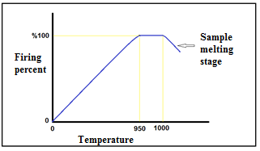

Fig.4 sketch Stages of burning ceramic samples

**4.6 Longitudinal shrinkage for fired samples**

**after burning :**

Longitudinal shrinkage is defined as the percentage decrease in the length of the sample after burning relative to its length before burning.

It occurs as a result of the loss of water, vapors and gases that occupy the pores in the clay samples before burning .

The longitudinal shrinkage depends on a many factors, the most important of which is the size and shape of the grains involved in the manufacture of bricks, as the longitudinal shrinkage increases and reaches 15% in fine-grained clays with high plasticity, and is very little in non-plastic sandy clays [17].

The longitudinal shrinkage of the ceramic samples was calculated by applying the equation (3) :

Linear Shrinkage = × 100 ……….. (3)

Where as : L1 is length before burning (mm) , L2 is Length after Burning (mm) .

Table9 showing thr results of longitudinal shrinkage in the study samples .

Table9: Longitudinal shrinkage for ceramic samples

|  |  |  |
| --- | --- | --- |
| **Sample** | **Shrinkage (mm)** | **Shrinkage %** |
| **D1,D2** | **0.092** | **0.92** |
| **G1,G2** | **-0.004** | **-0.4** |
| **G3,G4** | **0.007** | **0.7** |
| **G5,G6** | **0.013** | **1.3** |
| **G7,G8** | **-0.007** | **-0.7** |
| **G9** | **-0.016** | **-1.6** |
| **H1,H2** | **0.039** | **3.9** |
| **H3,H4** | **0.049** | **4.9** |
| **H5,H6** | **0.031** | **3.1** |
| **H7,H8** | **0.01** | **1** |
| **H9** | **0.03** | **3** |
| **H10** | **0.024** | **2.4** |
| **H11** | **0.025** | **2.5** |
| **P3,P4** | **0.02** | **2** |
| **P5** | **0.026** | **2.6** |
| **P6** | **0.034** | **3.4** |
| **Q** | **-0.005** | **-0.5** |

**4.7 Measurement of water absorption , apparent**

**porosity, bulk density :**

Water absorption is defined as the percentage of absorbed water to the dry body weight and is expressed as a percentage. It is one of the important measurements in the ceramic industries.

Several factors control the amount of water absorption for the fired brick, including: the size distribution of the grains, the percentage of clay minerals, and the percentage of non-clay minerals, especially calcite when it releases free calcium oxide by burning, which has a great ability to absorb water. It is formed in the body of the bricks after burning, as it leads to the absorption of a higher percentage of water [18].

As for porosity, it is defined as the percentage of the volume of voids (pores) relative to the total volume of the sample.

Porosity is of great importance in the ceramic industries, as it is an indicator of the acceptance of the ceramic body for glaze such as tiles, or for its acceptance of the bonding structural materials such as bricks, in addition to its extreme importance during various manufacturing processes such as drying and burning, because it allows the exit of water vapor and various gases from ceramic samples [16].

There are two types of porosity, which are apparent porosity or active porosity and closed porosity. Effective porosity in which the pores are interconnected and connected to the outer surface [19].

It has an effective effect on the different properties (mechanical and thermal) of the ceramic objects. The other type is closed porosity, in which the pores are isolated from the outer surface and have little effect on these characteristics. The total porosity is the sum of the closed and open pores. In this research, the apparent porosity was calculated.

The porosity decreases with the increase in the firing temperature of the ceramic objects due to the formation of the vitreous phase, which closes a percentage of the pores depending on the amount of vitreous material formed, which in turn depends on the type of components of the fired material, the grain size, the degree of burning, burning time, and soaking time [10] ; [20] .

The ceramic bodies formed by the method of semi-dry pressing of raw materials, which are in the form of a powder, whose grains before firing are separated from each other by pores ranging from (25-60)%. These pores depend on the size of the grains and the amount of pressure applied to them [2] .

As for the bulk density, it is the ratio of a certain weight to its total volume, which represents the volume of the solid with the volume of voids and open and closed pores. It is one of the important tests in the ceramic industries.

**Calculation method:**

The studied samples must be free of fractures and cracks, then they are put in a drying oven at a temperature of 110 degrees and left for 24 hours for the purpose of drying, after that the samples are weighed , then put in distilled water and completely immersed and left for 24 hours, then removed from the water and its surfaces are dried with a damp cloth and its weight is taken (representing the saturated weight), then it is weighed while it is completely immersed in water, but without the sample touching the base of the container. The equations (4) , (5) , (6) are applied :

Apparent Porosity % = × 100 ..……. (4)

Water absorption % = × 100 ..…....... (5)

Bulk Density = × *p1* …..….……… (6)

Where as : w1 is Dry weight, w2 is saturated weight, w3 is submerged weight, *p1* is Liquid density. by applying this equations , the result were obtained in the table 10.

Table 10: results of apparent porosity, water absorption, bulk density

|  |  |  |  |
| --- | --- | --- | --- |
| **Bulk Density** | **Water Absorption %** | **Apparent Porosity %** | **Sample** |
| **1.6** | **13.5** | **26.1** | **D1** |
| **1.5** | **17.6** | **33.3** | **G1** |
| **2** | **12.5** | **28.5** | **G9** |
| **1.8** | **13.3** | **28.5** | **G4** |
| **2** | **17.6** | **33.0** | **G6** |
| **2** | **5.2** | **11.1** | **Q** |
| **1.5** | **14.7** | **27.6** | **H4** |
| **1.7** | **16.6** | **35.7** | **H11** |
| **1.6** | **10** | **18.1** | **H2** |
| **1.5** | **17.6** | **28.0** | **P5** |

**4.8 Efflorescence measurement :**

efflorescence is defined as the amount of salts that accumulate on the surface of the fired bricks over time. The source of efflorescence is the salts presence in the soil. The efflorescence results from the process of wetting the bricks and then drying , so white salt appear on the surface of the bricks. The efflorescence is expressed in degrees (light, medium, high) (According to Iraqi Standard specification) [21] . This is done by putting the samples in a container vertically and immersing a quarter or less of it with distilled water for seven days. Every day, the water level is noted for the purpose of adding it if there is a decrease. Then the samples are taken out and putting in a well-ventilated room for three days (Fig. 5). The results of efflorescence on the surfaces of the samples are observed as In Table 11 .

Table 11: samples that appear efflorescence

|  |  |
| --- | --- |
| **Efflorescence** | **Sample** |
| **Medium** | **D** |
| **Small** | **G** |
| **Nil** | **P** |
| **Small** | **Q** |

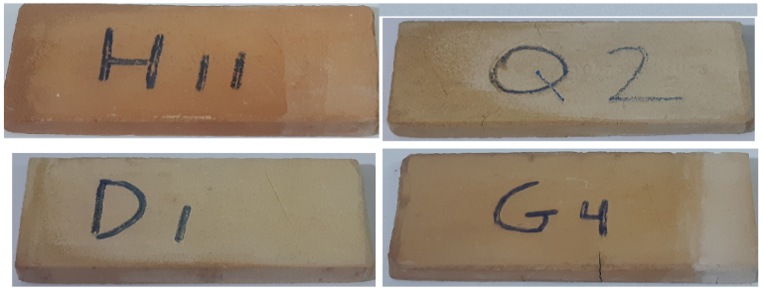

Fig.5 some samples after efflorescence test

**4.9 Compressive strength:**

It is one of the most important mechanical tests in the ceramic industries, which is the amount of pressure applied (Newton) on a certain area to know how much the body can withstand the pressure without breaking. The examination was carried out using an electro-hydraulic pressure machine , as the sample was putted between the two surfaces of the hydraulic press, and the pressure was applied gradually until the collapse occurred in the sample, as at this limit it represents the highest pressure that the sample can withstand , and the compressive strength was calculated by the equation (7):

S = ……………. (7)

where as : S is Compressive strength (nt./mm2) ,

W is stress amount applied when the collapse occurs (nt.) , A is Sample area (mm2)

The results of compressive strength table 12 compare with the Iraqi standard specification [21] table13 .

Table 12: result of compressive strength

|  |  |  |  |
| --- | --- | --- | --- |
| **Compressive strength (nt./mm2)** | **Sample** | **Compressive strength (nt./mm2)** | **Sample** |
| **30** | **H2** | **18** | **D1** |
| **22** | **H11** | **17.8** | **G1** |
| **28** | **P5** | **22** | **G4** |
| **16.1** | **Q2** | **18.7** | **G9** |
|  |  | **فاشل** | **G6** |

Table 13: Iraqi standards specification [20]

|  |  |  |  |
| --- | --- | --- | --- |
| **Efflorescence** | **Maximum of water absorption for one brick** | **Minimum Pressure for one brick (nt./mm2)** | **Category** |
| **Small** | **22%** | **16** | **Class A** |
| **Medium** | **26%** | **11** | **Class B** |
| **ـــــــــــــــ** | **28%** | **7** | **Class C** |

1. **Conclusions**

The results of chemical analysis showed that the oxides of the clays of the study area are close to the results of the oxides of Nahrawan clays , which are listed in Table2 . this is indicator for the validity of clays of study area for the purposes of ceramic industries .

The SO3 and Cl percentage were present in very little percentages, therefore the florescence rate was little ratio .

By comparing the results of the plasticity index for study area shown in Table 6 with the classification of Budinkov [14] shown in Table 7, it is showed that the study areas (Al-Hujaira , Hsaiba alsharqiea , Al-Chiffa) showed super plastic, This means that the clays of these areas can be formed and take on a plasticity suitable for ceramic industries.

From the water absorption results showed in Table10 and its comparison with the Iraqi Standard specification [21] showed in Table13 it is clear that the samples of study area showed water absorption less than 22% i.e. within category class (A) .

From the Table11, showed that the samples that related to (Al-Hujaira and Nahrawan area) showed small efflorescence and the sample that related to Hsaiba Alsharqiya showed medium efflorescence and Al-Chiffa area did not show efflorescence , and with Comparing the results with the Iraqi standard specification in [21] Table13, efflorescence of Al-Hujaira , Nahrawan and Al-Chiffa areas are classified within category class (A), Hsaiba Alsharqiea is classified within category clss (B) .

From the results of shrinkage we notice some of samples showed enlargement of the brick size (negative longitudinal shrinkage) , it may be caused by the absence of outlet or pores in the brick body to lead to the exit the gases such as carbon dioxide, as well as the presence of percentage of free calcium oxide liberated from calcite during burning and capable of absorbing water from the atmosphere. Or rain, as it leads to an increase in the size of the bricks [17].

From the Table12 the samples of study area that showed compressive strength above 16 nt./mm2 and with comparing this results with the Iraqi Standard specification [21] in Table13, this results are classified in category class (A) .

From the results of compressive strength in table12 showed Hsaiba Alsharqiea and Al-Hujaira1, Al-Hujaira2 that achieved the highest compressive strength in un treated samples, therefore it does not need any treatments or additions . Al-Chiffa area achieved higher compressive strength in the sample P5 therefore it need to addition 10% silica sand to clays . And the best burning temperature is 950 degree .

**Acknoledgment :**

The authors would like to express their gratitude to ministry of science and technology and german laboratory in geology department/collage of science/university of Baghdad to Their commendable contributions in chemical analysis (XRF) . and The authors are grateful to GEOSURV Iraq to provide us with valuable information and references, and the authors would like to express their gratitude to all the staff of the Journal .

**References :**

[1] Awadh, S.M. and Al-Owaidi, M.R., 2020. Application of triangles method for quantitative estimation of marl reserve in Euphrates formation, middle of Iraq. The Iraqi Geological Journal, 53 (2A), 35-49.

[2] Kingery, W.D., 1963. Introduction to Ceramics. John Wiley and Sons,Inc., New York,781PP.

[3] Sissakian, V. K. and Mohammed, B. S., 2007 , Stratigraphy, Iraq bulletin of geology and mining, volume special issue , issue1, 51-124.

[4] Jassim, S.Z. & Goff, J.C., 2006.Geology of Iraq. Published by Dolin, Prague and Moravian Museum, Brno, PP: 341.

[5] Sissakian, V. K. and Muhammad, S. M.,1994, Ramadi plate report, Geosurv Iraq, internal report.

[6] Al-Sayab et al., 1982, Geology of Iraq, University of Musul, published by national library, Baghdad, 1982, PP277. (in Arabic) .

[7] Surdashy A. A. & Aqrawi A. M., 2021, Assessment of Clay Deposits Quality from East of Erbil, Kurdistan Region, Iraq for some Ceramic Industries,The Iraqi Geological Journal, 54 (2F), 144-160 .

[8] Bolus, G.M. et al., 2005, report on evaluation of Nahrawan clays for bric industry, GEOSURV Iraq, internal report. (in Arabic) .

[9] Nesse, W.D., 2000. Introduction to mineralogy, oxford university press, 442p.

[10] Ryan, W., 1978. Properties of Ceramic raw materials, 2nd edition. Pergamon Press, Oxford, 113pp.

[11] ASTM Standard D4318, Standard test methods for liquid limit, plastic limit, and plasticity index of soil, [https://www.ASTM.org](https://kashanu.ac.ir/Files/D%204318%20-%2000%20%20_RDQZMTG_.pdf) , 12/3/2023 .

[12] Grim, R.E., 1962. Applied Clay Mineralogy, 20, McGraw-Hill, Book Co. Inc. New York , 422PP.

[13]Jamal, Haseeb. ["Atterberg's limits”.](https://www.aboutcivil.org/atterberg-limits.html) *AboutCivil.Org*., <https://www.aboutcivil.org/atterberg-limits>, 15/2/2023 .

[14] Budinkov, P.P., 1964. The technology of ceramics and refractories, Massachusetts Institute of technology.

[15] Awad, A. M. & Awadh, S. M., 2021, Manufacturing Perforated and Ordinary Bricks Using Injana Claystone Exposed in The Middle of Iraq, Iraq Geological Journal, 54 (1A), 11-22 .

[16] Al-Nuaimy, M. A., 1996, The effect of silica type in the physical and mechanical properties of ceramic bodies used as building materials, unpublished Master Thesis, collage of science, university of Baghdad, 95 PP . (in Arabic) .

[17] Al-Qazaz, D., et al., 2005, Reevaluation of the soil suitable for mud industry, Al-Sowera brick factory. GEOSURV, Iraq. Internal report (Arabic).

[18] Al-Hakeem, Farhad. A., (1998). evaluation of some neogene clays in north of Iraq for the purpose of ceramics, un published Master Thesis, collage of science, university of Baghdad, 100 PP. (in Arabic) .

[19] Selly, R. C., 2000: Applied Sedimentology,

second edition, London, United Kingdom,

523 PP.

[20] Norton, F.H., 1974, element of Ceramics, second edition, Addison- Wesley Publishing Company Inc., 311P .

[21] Iraqi Standard Specification (ISS No.25) , for the year (1993) : Clay Bricks (the other) Central organization for standardization and quality control, Baghdad, Iraq. (In Arabic).

**دراسة الخواص الفيزيائية والكيميائية لاطيان تكوين انجانة في محافظة الانبار- غرب العراق وتقييمها لاغراض الصناعات السيراميكية**

**احمد اديب منصور1* ، محـمد احمد النعيمي1**

1قسم الجيولوجيا التطبيقية، كلية العلوم، جامعة الانبار، العراق

*[ahm21s4001@uoanbar.edu.iq](mailto:ahm21s4001@uoanbar.edu.iq)

**الخلاصة:**

تم تقييم اطيان تكوين انجانة في محافظة الانبار لاغراض الصناعات السيراميكية من خلال تقييم الصفات الفيزيائية والكيميائية ومقارنة النتائج مع المواصفات القياسية . وقد تم تحضير (13) خلطة تختلف فيما بينها من خلال اضافات نسب مختلفة من الرمل . واستخدام اربع درجات حرارة للحرق (850 ، 950 ، 1000 ، 1100) م وذلك لبيان ماهي افضل خلطة وافضل درجة حرارة حرق تحقق نتائج تكون مقاربة للمواصفات القياسية . كانت نتائج الفحوصات الفيزيائية كالاتي : التقلص الطولي بعد الحرق يتراوح بين (-0.5 – 0.92) ، المسامية الظاهرية تتراوح بين (11.1 – 35.7) ، التزهر يتراوح بين (معدوم – متوسط) ، قوة الانضغاطية تتراوح بين (16.1 – 30) نت/مم2 . كما واظهرات نتائج التحاليل الكيميائة للأكاسيد ان نماذج منطقة الدراسة تحتوي على الاكاسيد الرئيسية التالية : نسبة اوكسيد السيليكون تتراوح بين (45.1 – 36.15) ، نسبة اوكسيد الالمنيوم تتراوح بين (8.64 – 14.05) ، نسبة اوكسيد الكالسيوم تتراوح بين (17.05 – 24.79) ، نسبة اوكسيد الحديد تتراوح ببين (0 – 7.25)% ، نسبة اوكسيد التيتانيوم تتراوح بين (0.96 – 1.01)% ، نسبة اوكسيد البوتاسيوم تتراوح بين (1.16 – 3.149% ، نسبة اوكسيد الصوديوم تتراوح بين (0.32 – 2.11)% ، نسبة ثلاثي اوكسيد الكبريت تتراوح بين (0.23 – 1.32)% ، نسبة الكلور تتراوح بين (0 – 0.47)% . وقد تبين ان افضل حرارة للحرق هي 950 درجة مئوية . كما وبينت نتائج الفحوصات الهندسية (حدود اتربيرغ) لنماذج الدراسة بأن نماذج الدراسة تحتوي على لدونة بصنف (Super plasticity) حسب تصنيف (Budinkov,1964) وهذا يعني ان اطيان منطقة الدراسة تستطيع ان تتشكل وتأخذ اللدونة المناسبة للصناعات السيراميكية . ومن خلال مقارنة نتائج الفحوصات الفيزيائية للطابوق المصنع ومقارنة النتائج مع حدود المواصفات القياسية العراقية رقم 25 لسنة 1988 تبين ان اطيان منطقة الدراسة صالحة لصناعة الطابوق وبصنف (أ) وحسب الخلطات المذكورة في الجدول 8 ماعدا النموذج G5 , G6 فقد اثبت فشله بسبب استخدام الرمل الاحمر حيث الاملاح الموجودة في الرمل عملت على افشال النموذج .