The Effect of Grain Size of Reinforcing Material (Corn Cob) on Some Mechanical Properties of the Composite Material.
Omar T. Mohammed , Waleed B. Salih
Department of Physics, College of Education For Pure Science, University of Anbar, Ramadi, Anbar, Iraq;
ARTICLE INFO |  |  | ABSTRACT
Received: 29/ 07 /2023  Accepted: 13/ 08 / 2023  Available online: 18 / 12 / 2023  DOI: 000000000000000000000 |  |  | Corn cob (CC) is an agricultural waste that can be recycled and used to reinforce unsaturated polyester resin, which can be utilized to produce low-cost structural sections, as well as reduce the risk resulting from the disposing of these wastes by traditional methods, such as landfilling or burning. The purpose of this research is to study the grain size effect of the reinforcing material particles on the mechanical properties of the composite material represented by (hardness, impact resistance, and compressive strength). The experimental work is carried out by preparing a polymeric mixture of unsaturated polyester resin (UPE) reinforced by corn cob particles using two different grain sizes of (53) µm and (710) µm with different volumetric fractions of (0, 5, 10, 20, and 30)%. The manual molding method was used in preparing the molds as follows: The first group consists of a polymeric mixture reinforced with corn cobs with a granular size of (53) µm using the same volumetric ratios mentioned above, while the second group consists of a polymeric mixture reinforced with corn cobs with a granular size of (710) µm using the same volumetric fractions of the first group. The results suggested that the reinforcement of the matrix by these particles led to improving the mechanical properties of the composite material by increasing the reinforcement ratios.  .
Keywords:
corn cob, unsaturated polyester,
hardness,impact strength,
compressive strength,
Copyright Authors, 2022, College of Sciences, University of Anbar. This is an open-access article under the CC BY 4.0 license (http://creativecommons.org/licens es/by/4.0/).

Introduction:
Ships, sports equipment, construction, and household applications [1] are examples of fields that utilize polymer composite materials with good mechanical properties, such as high strength, hardness, lightweight, and high corrosion resistance [2]. Most of the composites available in the market today are produced to be more durable and stronger in order to have a longer lifespan. To achieve these specifications, producing companies tend to use non-biodegradable fillers and fibers, which are non-renewable materials [3].
One of the disadvantages of these composite materials is the problem of disposal after their usage. In particular, polymer composites are non-degradable, thereby posing a serious threat to the environment and prompting researchers to seek sustainable and biodegradable raw materials that are also economical [4].
*Corresponding author at: Department of Physics, College of Education For Pure Science, University of Anbar, Ramadi, Anbar, Iraq; ORCID:https://orcid.org/0000-0002-0525-9172;Tel:+964xxxxxxx
E-mail address: esp.wal eedb.salih@uoanbar.edu.iq

Recently, the demand for recyclable and biodegradable materials, such as corn cobs (CC), hemp, bamboo, coconut, and flax, has increased for various applications to strengthen polymer materials, and hence, efforts were aimed at using their waste fibers, dust, and outer or inner shells to reinforce polymer and building materials. As a result, two benefits have been gained; firstly, getting rid of pollution from these wastes, and secondly, using these wastes to reinforce certain materials. Thus, recycling has become a priority in industrial societies today [5]. In this regard, environmental waste, in general, is a secondary product resulting from human activities, and natural fibers and dust are types of environmental wastes that are considered renewable sources of energy. Therefore, a new era of polymer-based composites has begun, and developing composite materials reinforced with dust, fibers, or other viable resources has recently become an important topic due to increasing environmental awareness [6]. To this end, the purpose of this research is to invest the environmental plant wastes represented by corn cobs in reinforcing polymeric-based structural sections and study the effect of the granular size of the reinforcing material on some mechanical properties, such as hardness, impact resistance, and compressive strength.

Experimental Part:
1. Materials Used:
1.1. The Matrix (Unsaturated Polyester):
Unsaturated polyester resin has been used as a base material, which is in the form of a transparent liquid with a moderate viscosity (Saudi origin) and a density of (1.2) g/cm³. This material can be processed to be solid by adding a transparent hardener, which is a compound of methyl ethyl ketone peroxide (MEKP) at a rate of (2) g per (100) g of resin. Moreover, to increase the rate of hardening of the resin, cobalt, a dark liquid, is added in droplets at a rate of (0.2) g per (100) g of resin. After about (30) minutes, it begins to transform into a gelatinous material (Gel) at room temperature.

1.2. Reinforcement Material:
Corn cobs primarily exist in the inner layer of a corn kernel, and their chemical composition consists of 47.42% cellulose, 12% hemicellulose, 31.91% lignin, and 8.67% carbon ash. Corn cobs are considered essential waste as they constitute 18.23% of all parts of the plant, and one kilogram of corn grains produces (0.15)kg of corn cobs [7]. In this work, corn cobs were collected from the corn plant in Iraq and were extracted by special mechanical methods, where they were cleaned and washed in distilled water and then dried using an electric oven at a temperature of (100) °C for (60) minutes. Next, they were broken into small parts with a hand crusher and then ground utilizing an electric grinder. After that, the powder was sieved to obtain the granular sizes required for this research. Specifically, a particle size of (53) µm and another of (710) µm were obtained, as shown in Fig.1.
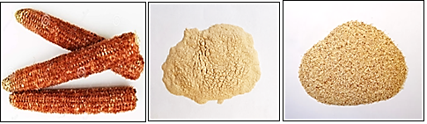
Figure 1. Curing process of corn cobs.
2. Composite Material and Mechanical Tests:
The manual molding method was used to prepare the samples with an aluminum mold that was manufactured with the required dimensions of samples according to international specifications. In particular, the samples were prepared according to the volumetric fractions considered for this research, namely (0, 5, 10, 20, and 30)%. The unsaturated polyester (UPE) was gradually mixed with its hardener at a ratio of 2:100g using a glass rod to ensure that it does not form bubbles and to reach the state of homogeneity. Next, corn cob particles with a granular size of 53 µm were continuously added to the unsaturated polyester to obtain the particles’ volume fraction of 5%. This process was repeated for the other volume. The volume fraction of particles V_{f}, which is related to the weight fraction of particles Ψ, can be calculated using the following mathematical relationships (Eq.1, Eq.2, and Eq.3) [8]:
$Vf=\frac{1}{1+\frac{1-Ψ}{Ψ} x \frac{ρ_{f}}{ρ_{m}}}$ (1)
$Ψ=\left(\frac{W_{f}}{W_{c}}\right)x100\%.$ (2)
$W_{c}=W_{f}+W_{m}$ (3)
where $W_{c}$, $W_{m}$, and $W_{f}$are the weight of the composite material, the matrix, and the reinforced material, respectively, measured in g units.
$ρ_{f}$ and $ρ_{m}$are the density of the composite material and the reinforced material, respectively, measured in g/cm³ units. The composite was carefully poured into the metal mold, and then the sample was left inside the mold for hardening. When the molding process was completed, the sample was cured by heat using an electric hot air oven at a temperature of 50 °C and for 60 minutes to complete the hardening process, to obtain the best overlapping for the polymeric chains, and to eliminate the stresses generated on the sample during the casting process. In this work, the mechanical properties of the composite material represented by hardness were studied according to international standards ASTM D2240, impact resistance ISO-180, and compressive strength ASTM D695-15 [9, 10, 11].

3.Results and discussion:
1.3. Hardness Test:
It is an essential mechanical test that gives an idea of the surface resistance to scratch and penetration of the polymeric material. The hardness test was carried out using the (Shore-D) device specifically the HUATEC GROUP Hardness Tester HT-6600C Shore D, manufactured by HUATEC, a Chinese company. The device consists of a needle-shaped indentation tool that penetrates the surface of the sample to record the hardness value. All hardness tests were performed at a laboratory temperature of 27°C. The samples were prepared according to the international American specifications [ASTM-D 2240]. Five readings were taken for each sample, and the average of these readings was determined to obtain the hardness value. Figure 2 illustrates the hardness test samples for both groups G1 and G2. From the results that were obtained and shown in Fig. 3, it was found that there is a significant increase in the hardness values when increasing the reinforcement with corn cobs particles, and we find that the highest value of hardness was at the volume fraction of 30% for both groups G1 and G2. The reason for this result is that the (CC) particles fill gaps and reduce voids that may have formed during the molding process. More specifically, the (CC) particles as a reinforcing material enhanced their spread within the matrix, thereby increasing the compaction between the components of the prepared samples, which reduces the movements of polymeric particles and then gives a better hardness [12]. In addition, the nature of the particles of the reinforcing material has a role in the reinforcing process. In particular, when the particles have high strength and hardness, they will improve the toughness of the resulting composite material. The particles’ size also affects the hardness of the composite materials, as small particles can easily spread in the polymeric liquid, which increases the bonding between the matrix and the reinforcing material, and then improves the sample’s test results [13]. This improvement was found in the first group G1 with a grain size of (53)μm, which achieved better hardness results.
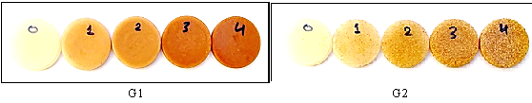
Figure 2. Hardness test samples for the two groups G1 and G2.
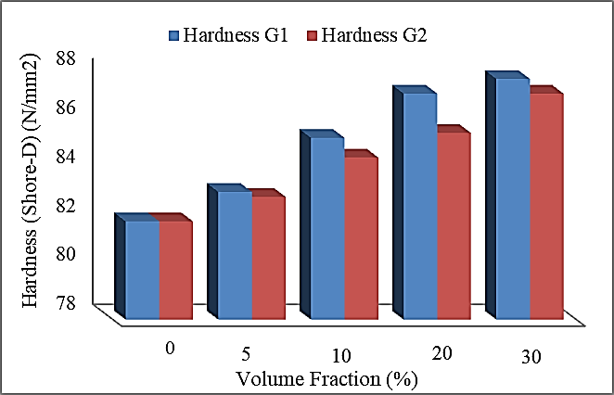
Figure 3. The relationship between the hardness and the volume fractions of the (CC) particles.

2.3. Impact Resistance Test:
The impact resistance test is one of the mechanical tests in which the sample is subjected to a rapid kinetic load, and the purpose of this test is to determine the amount of energy absorbed when the sample prepared from polymeric compounds is broken, to evaluate how it can withstand the sudden external stresses affecting it. The Charpy Test was used to measure the shock resistance of the prepared samples, and the testing device was manufactured by a Chinese company, namely (LAREE Your Testing Solution). This device is used to calculate the energy required for fracture, which can be used to determine the material's impact resistance, Figure 4 illustrates the impact resistance test samples that were prepared, while Fig. 5 shows the results of the impact resistance values, which showed that there was a significant improvement in the values for all samples when reinforced with the corn cob particles. Particularly, higher values were recorded than those in the case of pure resin. In this regard, the highest value of the impact resistance was obtained at a volumetric fraction of 30% for the first group G1 with a grain size of (53) µm by (0.53) KJ/m². This result is due to the presence of those grain particles, which bore a large number of impact stresses on the sample because these particles have good strength and impact properties, as stresses are transmitted from the matrix to the reinforcing material through the interface. In addition, the (CC) particles work to distribute the stresses over a larger sample area and thus reduce their concentration in a certain area, which in turn obstructs the growth of cracks and changes their shape and direction to turn into a set of secondary cracks. This change in the shape and direction of the crack and the energy that was used to cross the barriers all make the kinetic load distribute over the largest possible area, which is consistent with the results of the researcher in [14]. As for the second group, G2, with a grain size of (710) µm, it had the highest value of shock resistance at a volume fraction of 20%, which was (0.4) KJ/m². This outcome was obtained because the greater the reinforcement with very small particles, the better the impact resistance results because small particles can easily penetrate the matrix, which increases the contact between both the matrix and the reinforcement material while increasing the bonding between the components of the polymeric material [15]. The decrease in the impact resistance at the 30% volume fraction for samples reinforced with large corncob particles is due to the decrease in the particle contact area of (CC) with the matrix (UPE), which results in a decrease in the wetting process before the polymeric liquid solidifies, leading to weak bonding between the (CC) and the UPE, which causes the failure of the sample to be tested, as illustrated in the scanning electron microscopy images (SEM) [16].
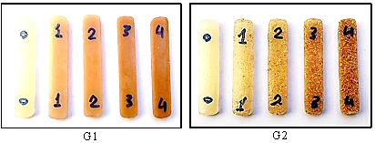
Figure 4. Impact resistance test samples for the two groups G1 and G2
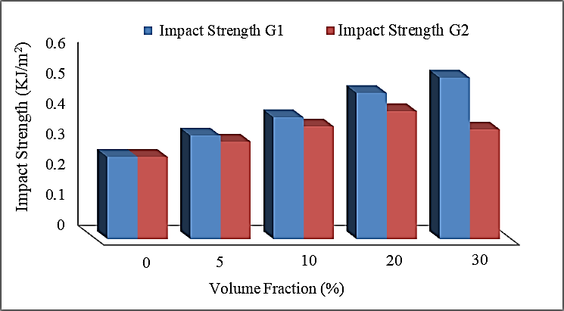
Figure 5. The relationship between the impact strength and the volume fractions of the (CC) particles.
3.3. Compressive Strength Test:
Compressive strength is defined as the maximum stress that a rigid material can withstand under vertical pressure applied to it, and it can be calculated by dividing the applied force by the unit area of the cross-section of the sample. In this test, a device (LAREE Yaur Tasting Solution ) was used to conduct tests for the samples of the prepared overlays, and this device was manufactured by a Chinese company, namely (Laree Technology Co. Ltd). Utilizing this test, the compression resistance of the samples was calculated when a compressive load was applied to them. In particular, the test was carried out when a compressive load was applied at a strain rate of (5 mm/min), and the results of the compressive strength were directly obtained through the device’s graph, where the samples were taken with standard dimensions in accordance with the American standard specifications. Figure 6 depicts the samples used for this test, and the results obtained, as shown in Fig. 7, are as follows: There is an improvement in the compressive strength values at specific volumetric fractions, where the highest value of the compressive strength was recorded for the first group with a granular size of (53) µm at a volume fraction of 20% by (46.78) MPa. Therefore, we conclude that a higher than 20% reinforcement percentage results in a decrease in the resistance of the composite material to the vertical forces exerted on it, while the second group with a granular size of (710) µm recorded the highest value of the compressive strength at the volume fraction of 5% by (24.4) MPa. The decrease in the samples’ resistance to the stress applied to them is due to the effect of the granular size of the corn cob particles because the increase in the size of the particles causes difficulty in the fluidity of the matrix and its penetration between the reinforcement particles, which reduces the wetting process of the corn cob particles before hardening (UPE), causing weakness in the adhesion between the matrix and the reinforcing materials [17]. In this context, the reinforcement with small particles is characterized by being symmetrical in all directions, in addition to the strong bonding of the interface between the particles and the matrix, as well as the small size of the particles resulting in small interfacial distances, which will obstruct the process of crack generation [18].
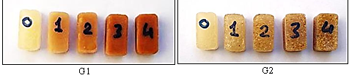
Figure 6. The compressive strength test samples for the two groups G1 and G2
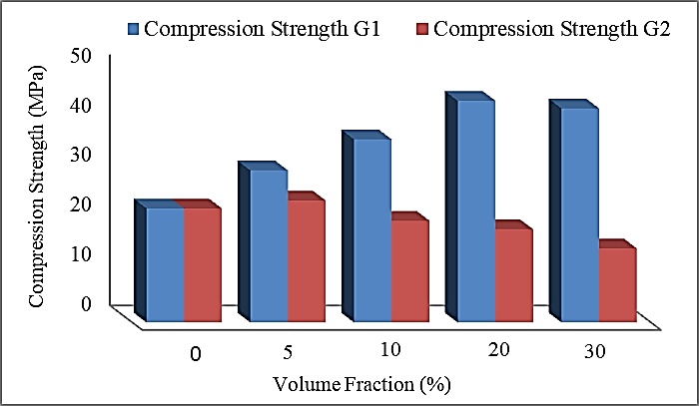
Figure 7. The relationship between the compression strength and the volume fractions of the (CC) particles.

4. Morphology Results Test:
1.4. Scanning Electron Microscopy (SEM):
A scanning electron microscope was used to examine the test samples at the fracture area to determine the cause of the failure that occurred for some of the test samples by giving a clear image of the process of arranging the reinforcement particles of the CC and their diffusion within the matrix (UPE). By observing Fig. 8A, we find that the particles of corn cob with a granular size of (53) µm spread homogeneously and densely within the matrix, forming a good composite material. While the samples that were reinforced with particles with a grain size of (710) µm, as shown in Fig. 8B, lack strengthening particles at the fracture area due to the large size of the particles.
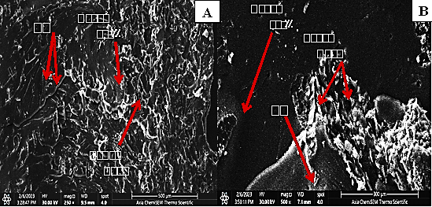
Figure 8. SEM photos of the fractured surface after the impact tests for 10 vol % (CC) filled UPE/polyester composite. (A) 53µm and (B) 710 µm of (CC).

Conclusion:
In conclusion, it would appear that environmental agricultural waste (corn cob) can be used to improve the mechanical properties (hardness, impact resistance, and compressive strength) of the composite material, and the particle size has an effect on the values of those properties.
References:
[1] Fried, J. R. (1999). Polymer Science and Technology, 2nd ed. Applied Publishers, London, 369-375
[2] Ashutosh, D., Anurag, T. and Chaturvedi, M. K. (2010). Plastic Waste and its Recycling. VSRD Technical and Non- Technical Journal; 1(1): 3
[3] Chattopadhyay, S. K., Singh, S., Pramani, K. N., Niyogi, U. K., Khandl, R. K. and Uppaluri, R. (2011). Biodegradability Studies on Natural Fibers Reinforced Polypropylene Composites. Journal of Applied Polymer Science; 121: 2226-2232
[3] Chattopadhyay, S. K., Singh, S., Pramani, K. N., Niyogi, U. K., Khandl, R. K. and Uppaluri, R. (2011). Biodegradability Studies on Natural Fibers Reinforced Polypropylene Composites. Journal of Applied Polymer Science; 121: 2226-2232.
[4] Chitra, J. N. and Vasanthakumari, R. (2012). Studies on Polypropylene Biocomposite With Cornhusk Waste Polypropylene Biocomposite With Cornhusk Waste Polypropylene Biocomposite With Cornhusk Waste, 3(7), 1-3.
[5] Hind, B, A.(2013). Effect of Reinforced by Coconut Fiber Core on The Mechanical Properties for Un-Saturated Polyester Matrix Composite Material, Engineering and Technology Journal , 31(17) , 296-308
[6] Sanjay .M. R , Arpitha. G. R. , Naik. L.L. , Gopalakrishna. K. & Yogesha B. (2016). Applications of Natural Fibers and Its Composites, Scientific Research Publishing Inc , 7(3) , 108-114
[7] Pratheep. V. G, Priyanka. E., Thangavel. S., Gousanal. J., & Antony. P. T. B. (2020). Kavin Kavin, nvestigation and analysis of corn cob, coir pith with wood plastic composites, Materials Today Journal, 45 (3)
[8] SAE International, (2012) Composite Material Handbook: Polymer Matrix Material, (3).
[9] Annual Book of ASTM Standard Test Method for Unnotched Izod Impact Testing of Plastic properties-Durometer Hardness, (2003) . D (2240-03), 1-12.
[10] Annual Book of ISO Standard, (2006) Standard Test Method for Unnotched Izod Impact Tasting of Plastic, ISO (180), 1-2
[11] ASTM D695-15, Standard Test Method Compressive Properties of Rigid plastics. Information on: https://www.astm.org/Standards/D695-15 .
[12] Yaseen. M. T, Al Saadi. M.A., Hussein. I., & Bdaiw.(2020). An Investigation of the Mechanical Properties of PMMA-based Composites Reinforced with PZT Ternary, Nanoparticles NeuroQuantology, 18 (2) 56-61.
[13] Salman. K. Noori. S., Abd-Alamer. A., & Mahmmod. L. (2014). Studying The Mechanical Properties Of Unsaturated Polyesters - B4C System, The Iraqi Journal For Mechanical And Material Engineering, 14 (1), 174-185
[14] Abbas. R. A, (2012). Study What Can be Achieved by the Lack of Flexural Strain Energy of Change for The Efficient Recovery of Novolak of The Elasticity As a Result of Fiber-Reinforcement, Engineering and Technology Journal, 30 (12), 284-301.
[15] M .Bikales, (2015). Encyclopedia of Polymer Science and Engineering, John Wiley, New York, 4
[16] Miritoiu. C.M, Nicolicescu. C., &Dinita A. (2021). A study About Some Mechanical Properties for Composites Reinforced with Corn Cob Powder, Material Plastic, 58 (4), 1-8.
[17] Abdullah MM. Z, Deyaa. B. M.,& Al saraf A. R. (2013). A study of the effect of temperature on some mechanical properties of single hybrid composites, Ibn Al-Haytham Journal of Pure and Applied Sciences, 24 (2), 49-65
[18] Hassan .M. A. S., Sallal. H. A., & Kahlol .K. K., (2013). Effect the Grain Size on the Polymer Matrix Composites Reinforced by Reenia Particles, Al-Khwarizmi Engineering Journal, 9 (2) 94-102.

تأثير الحجم الحبيبي لمادة التدعيم (كوز الذرة) على بعض الخصائص الميكانيكية للمادة المتراكبة

عمر ذاكر محمد وليد بديوي صالح
قسم الفيزياء، كلية التربية للعلوم الصرفة، جامعة الانبار، الانبار، العراق
oma20u3013@uoanbar.edu.iq esp.wal eedb.salih@uoanbar.edu.iq
الخلاصة:
يعد كوز الذرة(CC) من المخلفات الزراعية التي يمكن اعادة تدويرها واستخدامها في تدعيم راتنج البولي استر غير المشبع، حيث يمكن من خلالها انتاج مقاطع هيكلية واطئة الكلفة وكذلك التقليل من الخطر الناتج عن عملية التخلص من تلك المخلفات بواسطة الطرق التقليدية كالطمر او الحرق. يهدف البحث الى دراسة تأثير الحجم الحُبيبي لدقائق مادة التدعيم على الخواص الميكانيكية للمادة المتراكبة المتمثلة (بالصلادة، مقاومة الصدمة ومقاومة الانضغاط)، حيث تم تحضير خليط بوليميري من راتنج البولي استر غير المشبع (UBE) المقوى بدقائق كوز الذرة وبحجمين حُبيّبين مختلفين (53) µm و (710) µm وبكسور حجمية مختلفة (0, 5, 10, 20, 30)% واستخدمت طريقة القولبة اليدوية في تحضير القوالب وكما يأتي: المجموعة الاولى تتكون من الخليط البوليمري المدعم بدقائق كوز الذرة (CC) وبحجم حبيبي مقداره (53(µm وبالنسب الحجمية المذكورة اعلاه. اما المجموعة الثانية فتتكون من الخليط البوليمري المدعم بدقائق كوز الذرة CC)) وبحجم حبيبي مقداره (710) µm وبنفس الكسور الحجمية للمجموعة الاولى. وقد اظهرت النتائج ان تدعيم المادة الاساس بالدقائق ادى الى تحسن الخصائص الميكانيكية للمادة المتراكبة بزيادة نسب التدعيم.
الكلمات المفتاحية: كيزان الذرة، راتنج البولي استر غير المشبع، الصلادة، مقاومة الصدمة، مقاومة الانضغاط.

